Creating Google Compute Engine (GCE) is the service in GCP (Google Cloud Platform) to Provision and manage your virtual machines. GCE creates and manages the lifecycle of vms.(PPT page 24).

Go to cloud.google.com and click console

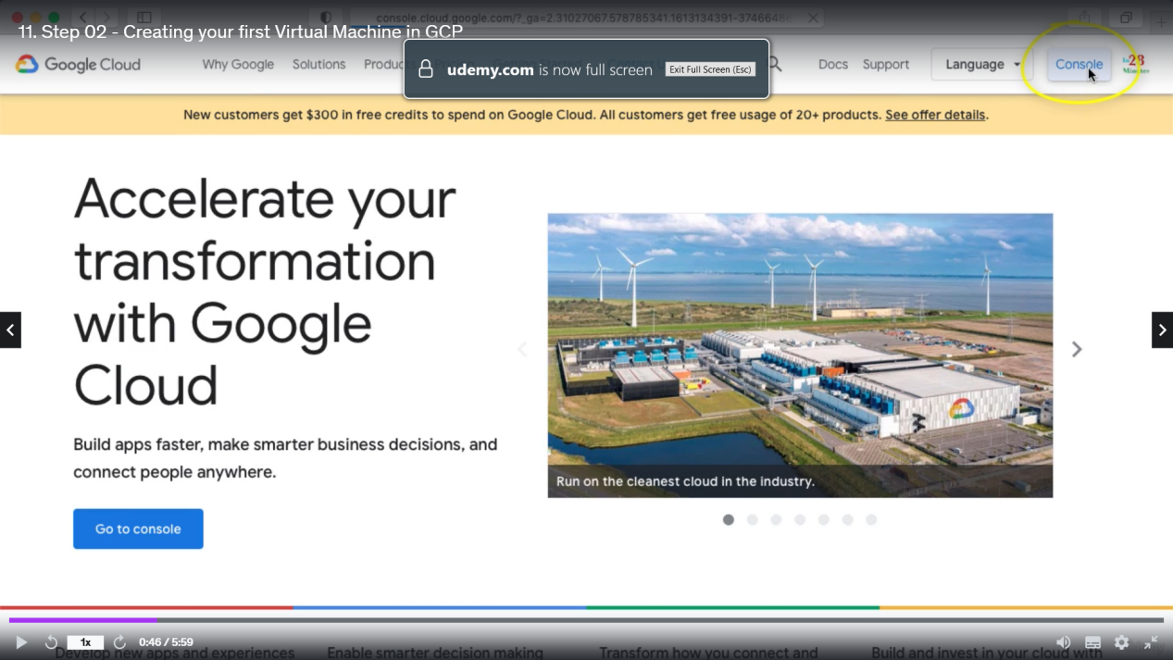

Search for compute engine.

First you need to give permission to Compute Engine API.

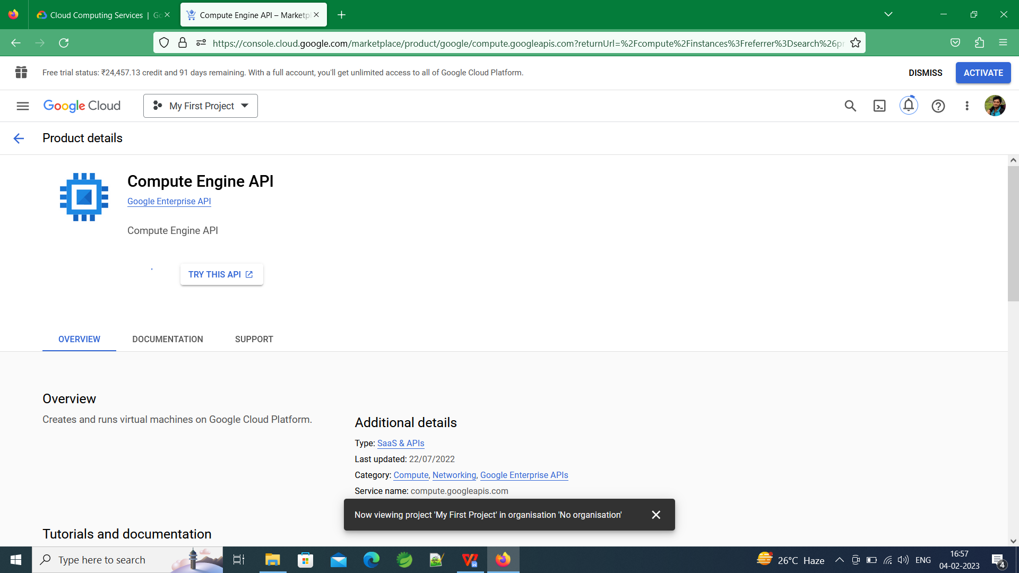

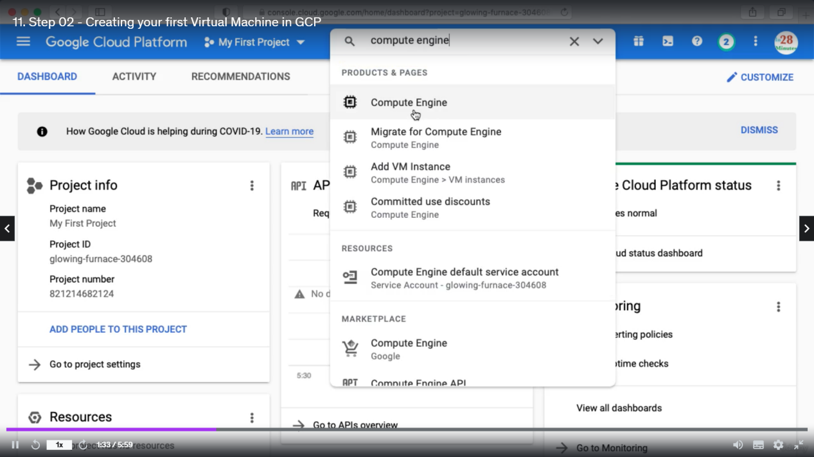

Now click create to create a VM instance

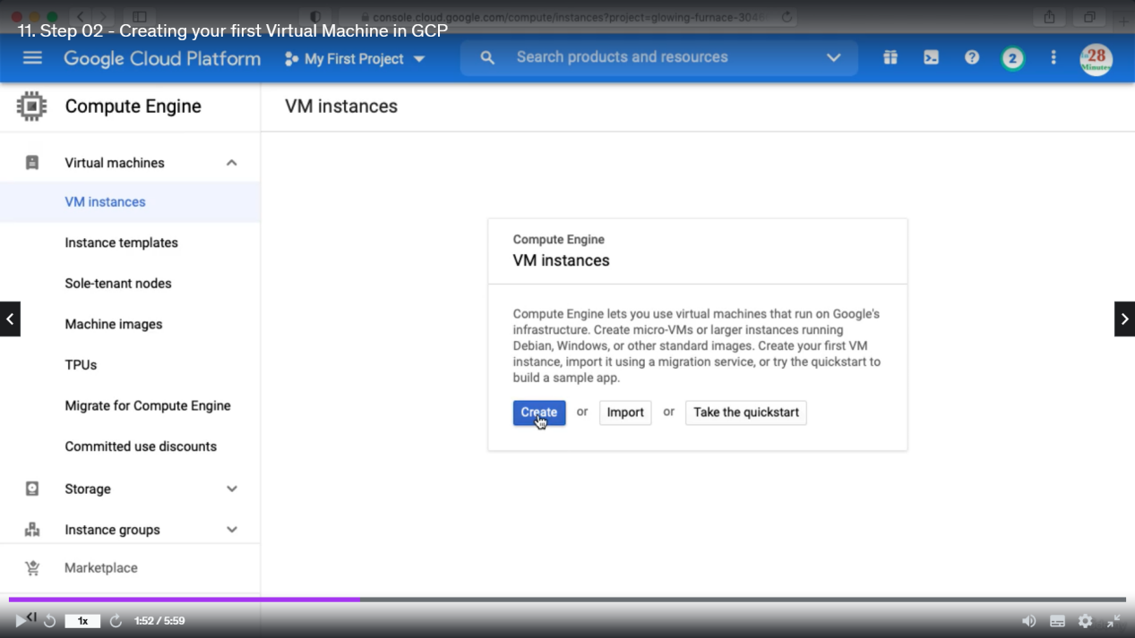

We need to enter below details regarding VM. Labels are the metadata of VM. Here we can choose the operating System also.

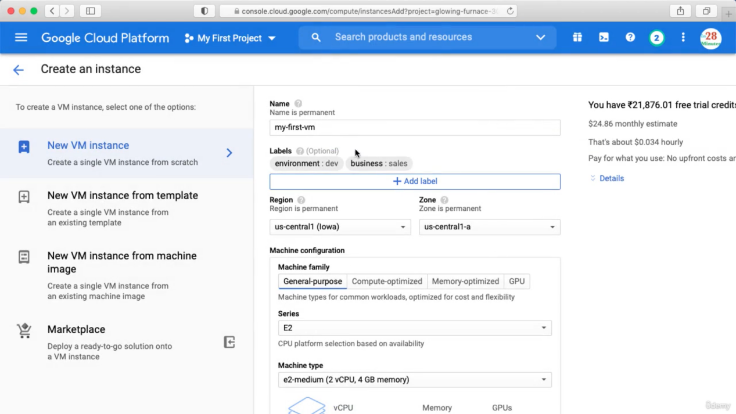

Firewall details can be used as below.

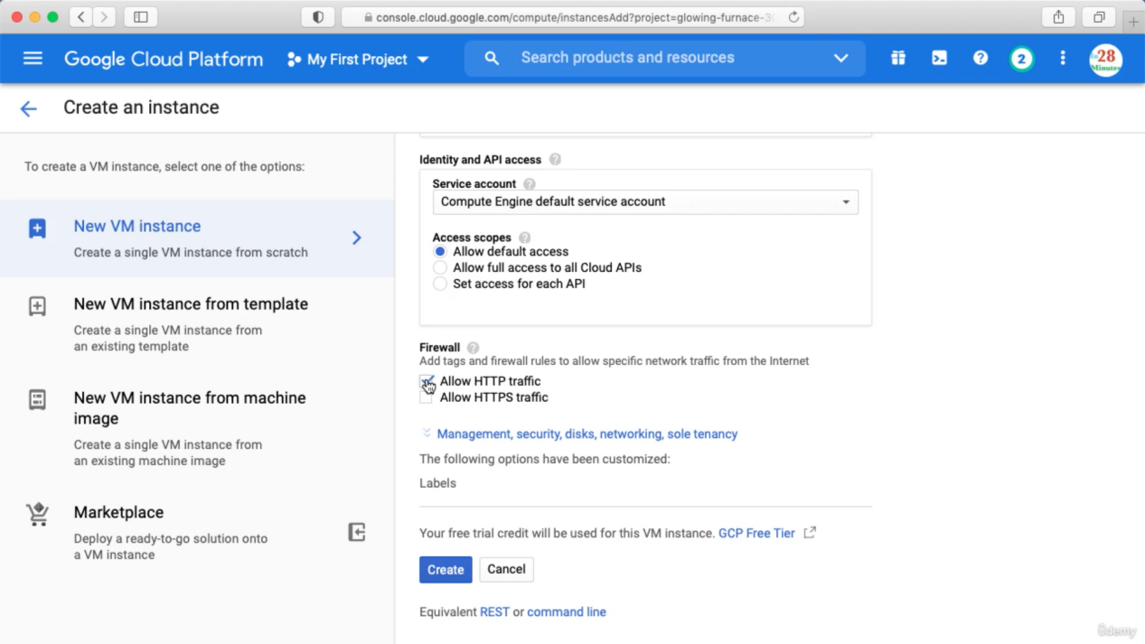

If we scroll a bit right we will be able to see the cost associated with this VM instance

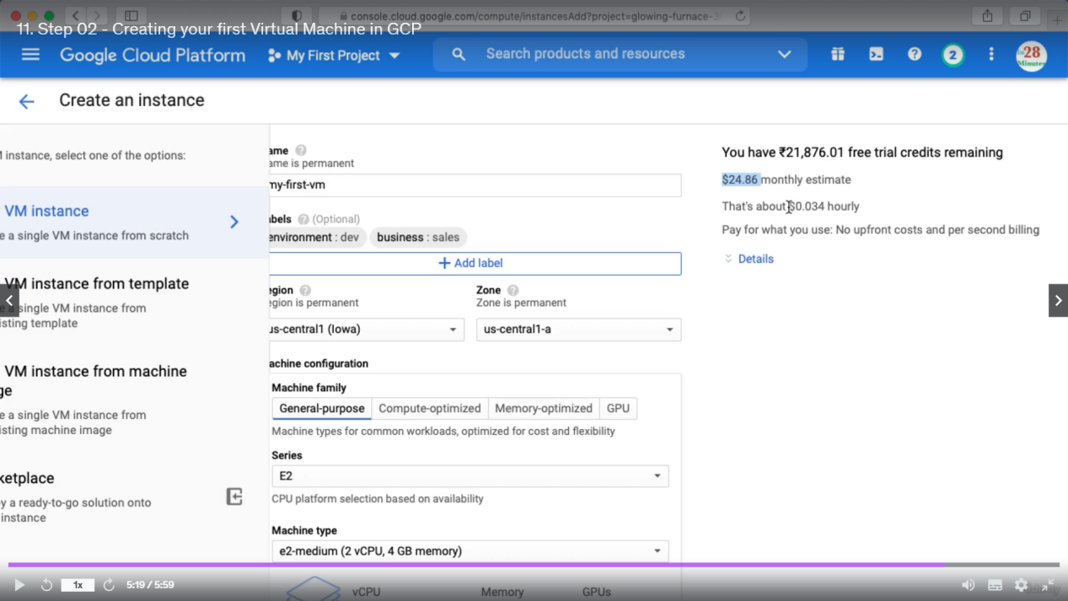

\*\* stop or terminate the instance when demo is done. Then click create, so we created a VM using google compute engine.

When the VM is created we will see one internal ip and one external ip is assigned to the VM.

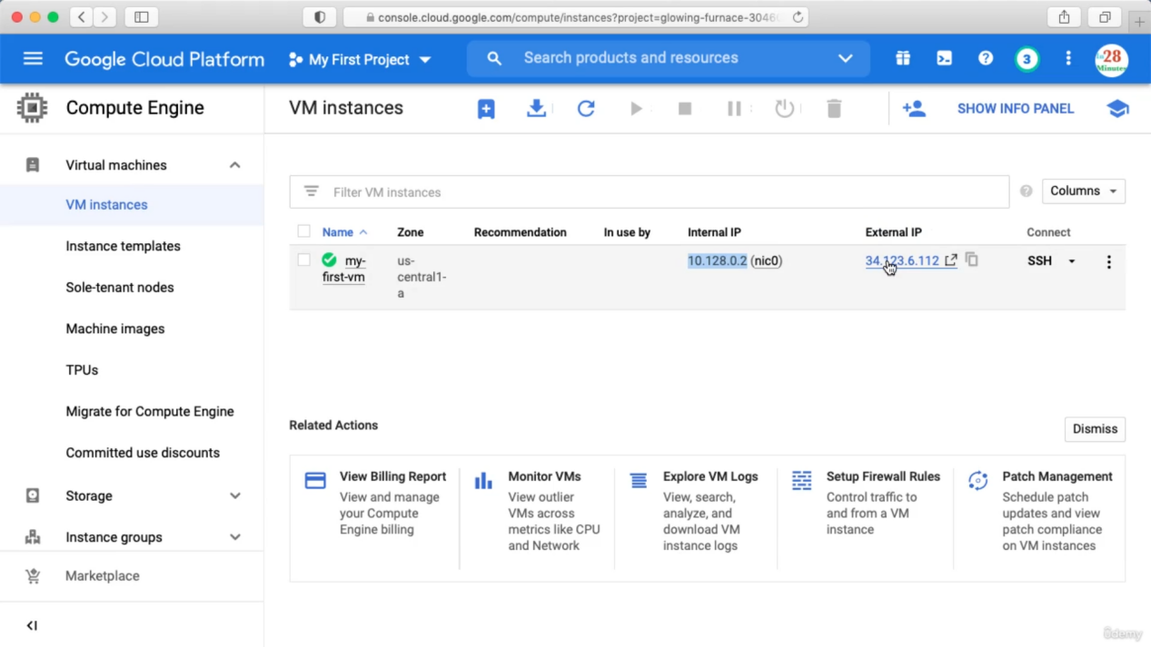

You can SSH the VM by clicking the SSH button or you can click the three dots and see different options.

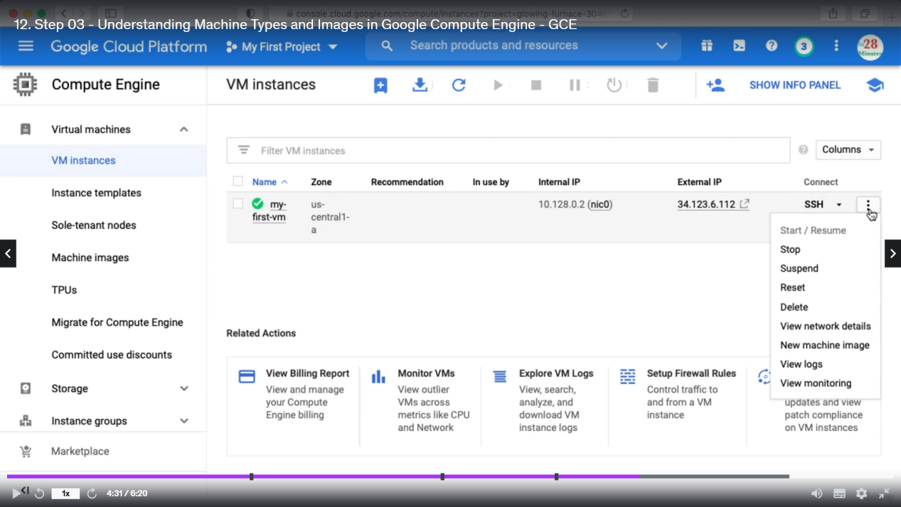

Suspend means pause.

Click SSH and you can run below commands.

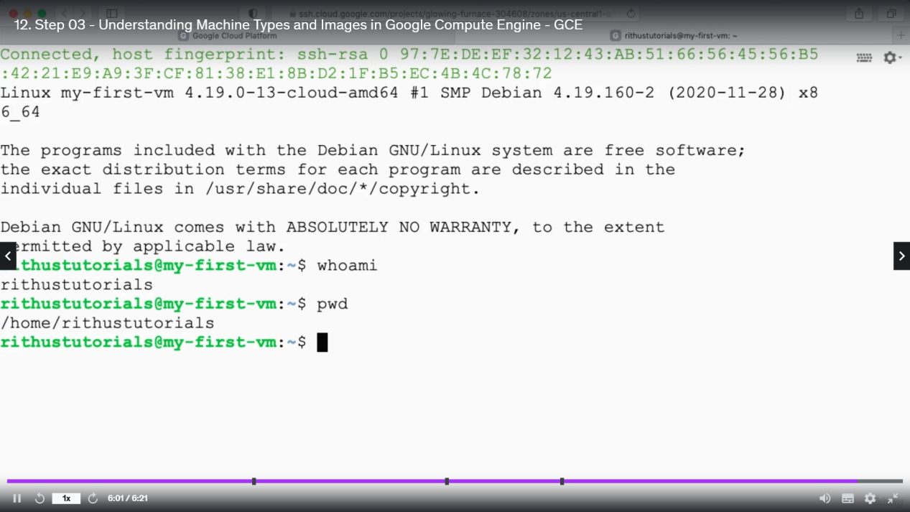

We need to install some software in VM and to do so we need to become the root user. (command to become root user: sudo su)

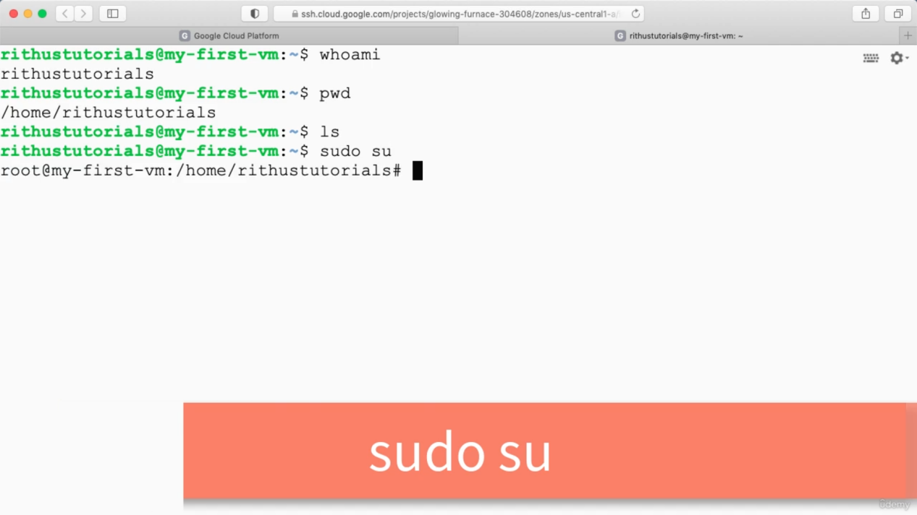

Apt update (apt is a package manager which is installed by default in Debient OS) apt update will install all the latest changes in the underlying software.

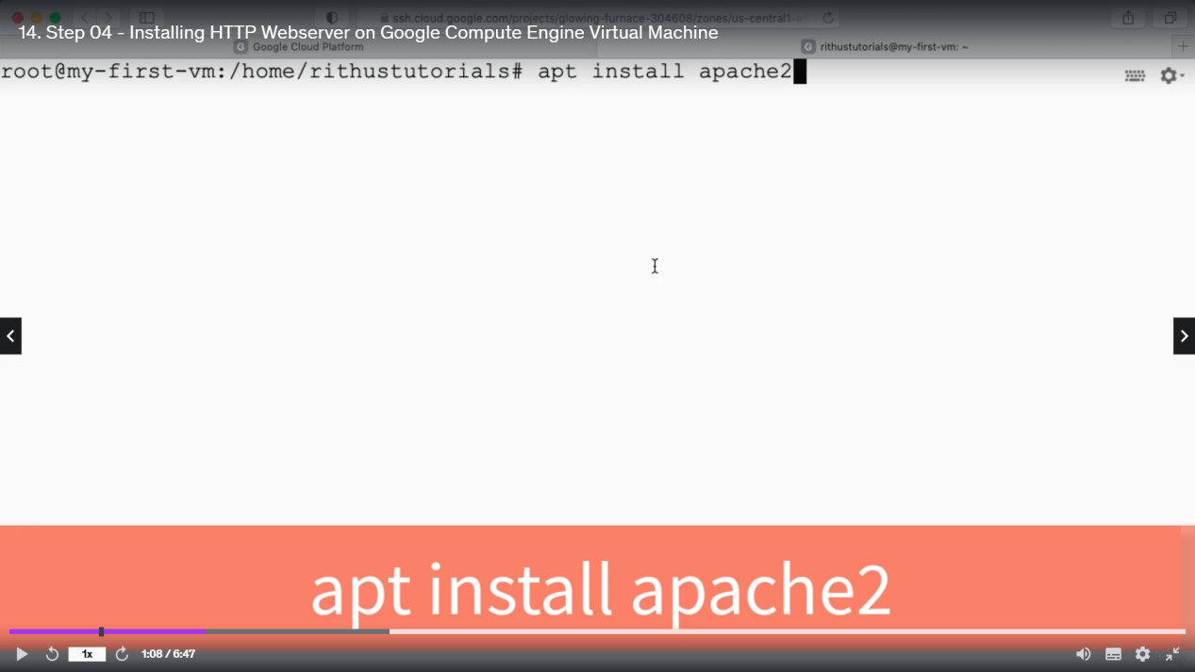

Above will install apache in vm.

Now if you open the external ip then apache page will open

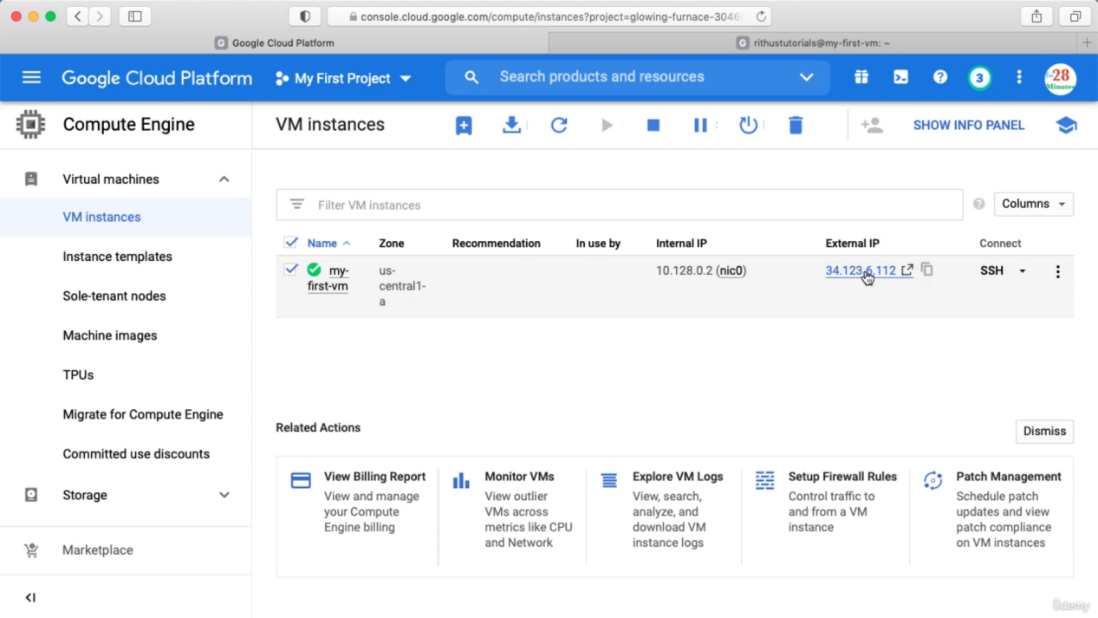

Here we will see the default page path and we can go to that path

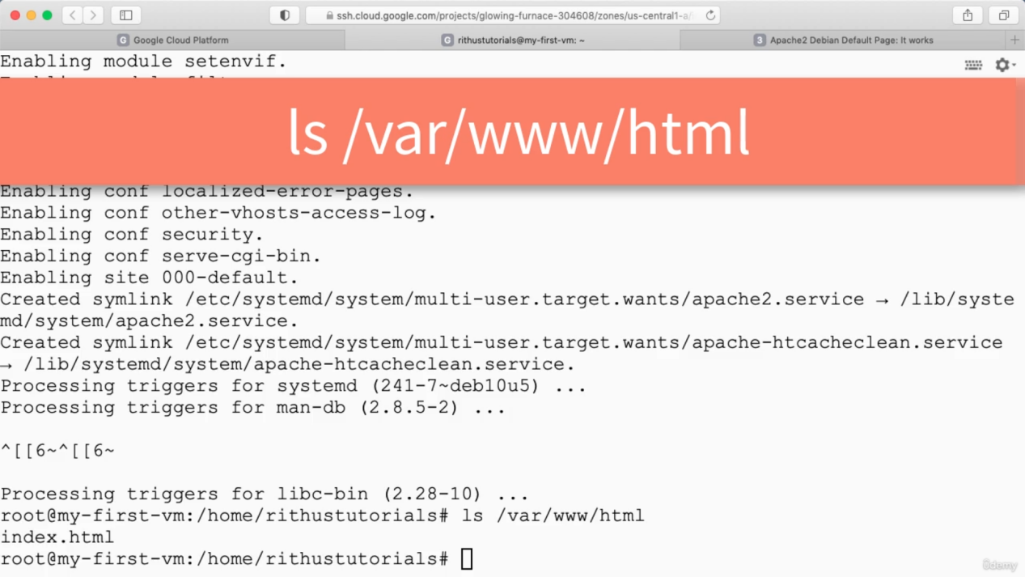

Now we can edit the index.html

Echo “hello” -> echo is like syso, we can test using echo.

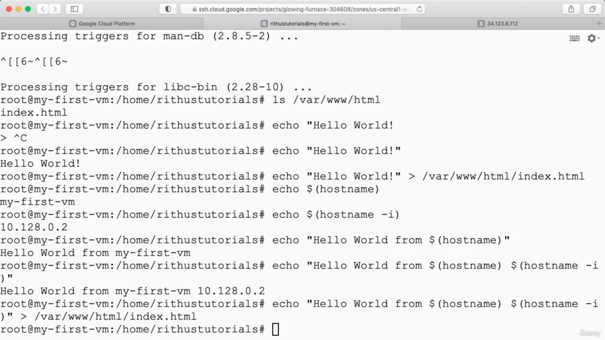

Now if we restart this VM then the external IP associate with this will get changed. So, we need to create a static external ip.

Creating static External IP

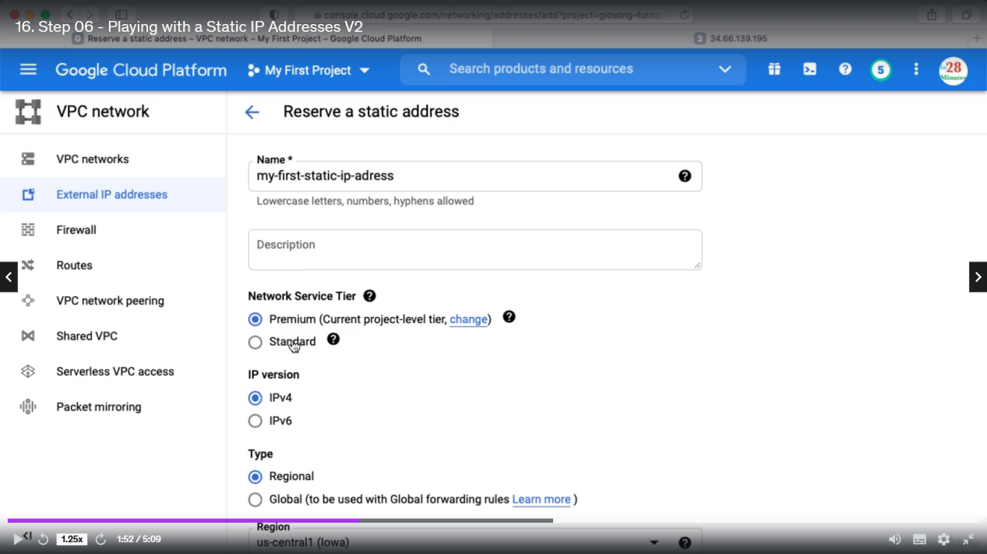

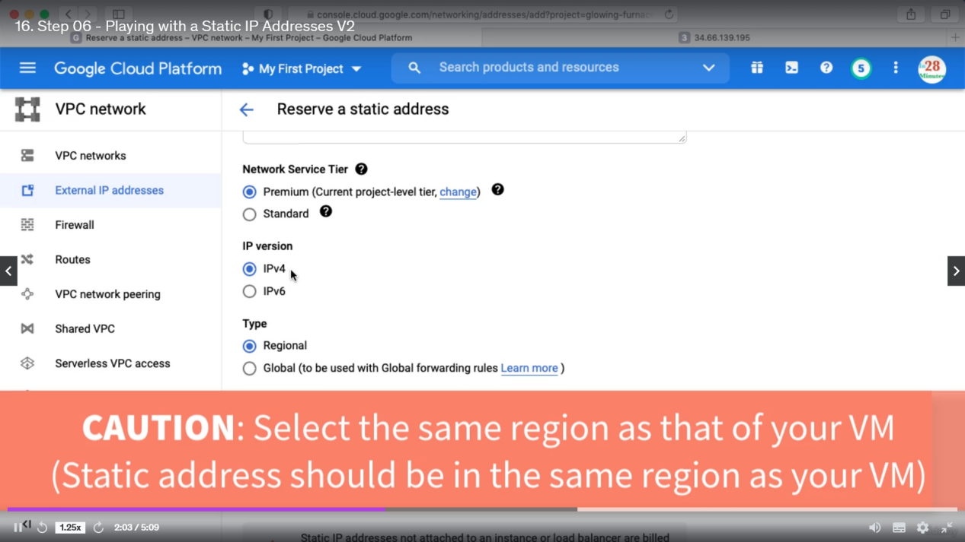

Then click create. And static IP will be created like below  
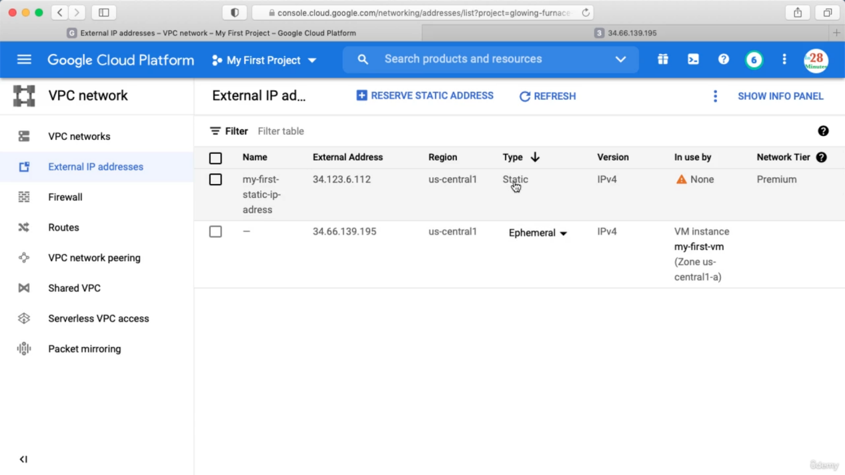

Ephemeral means changeable.

Assign Static Ip to VM. Click the change button  
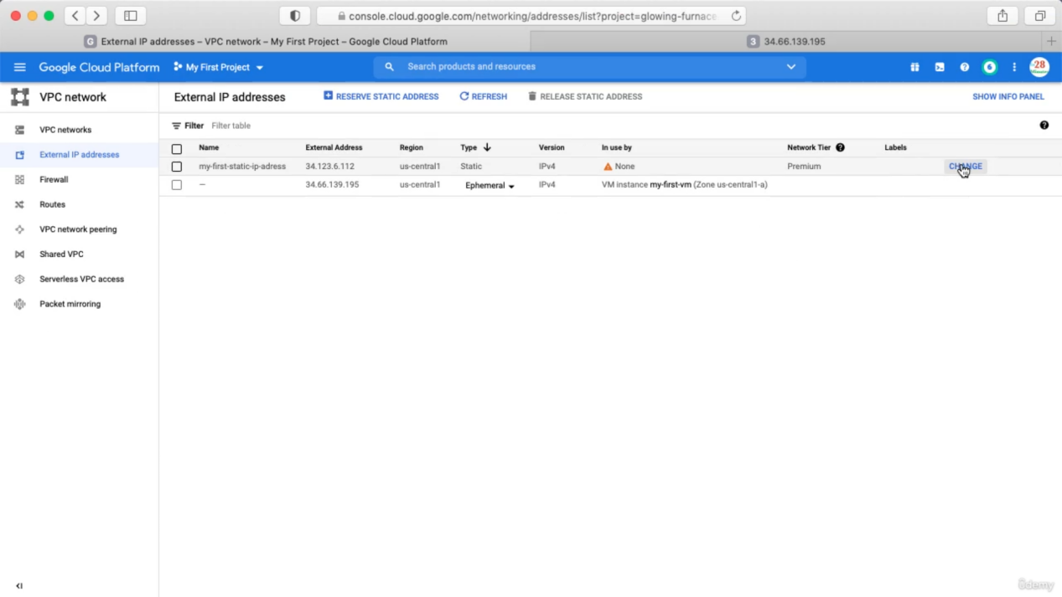

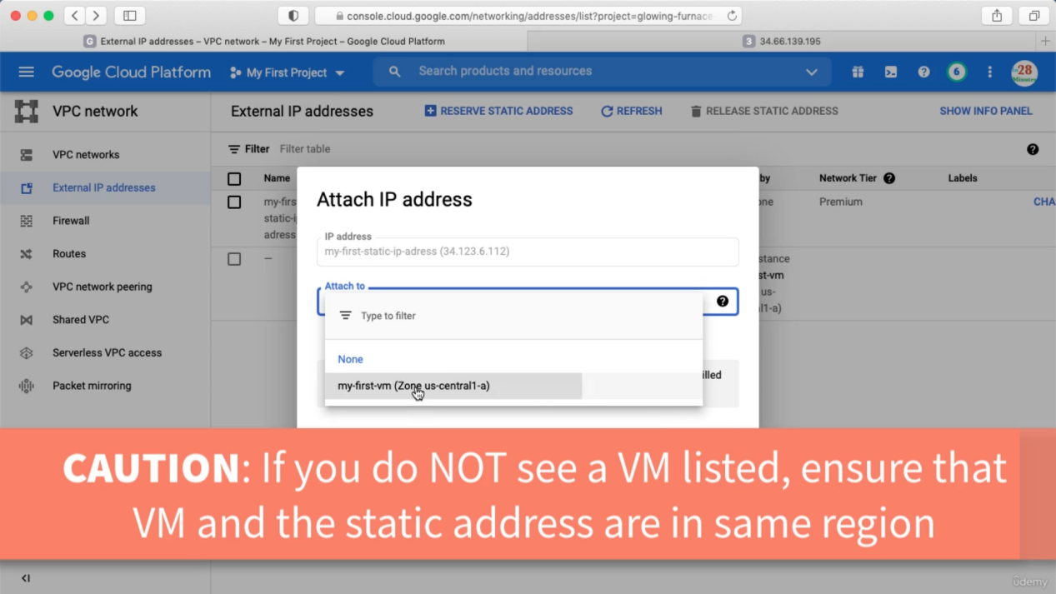

Now after refresh the ephemeral address will be released.

See VM instances

In Search type VM instances.

If we assign static address to our VM then even after stopping the VM the static address remains assigned. So, we can assign this static ip to another VM.

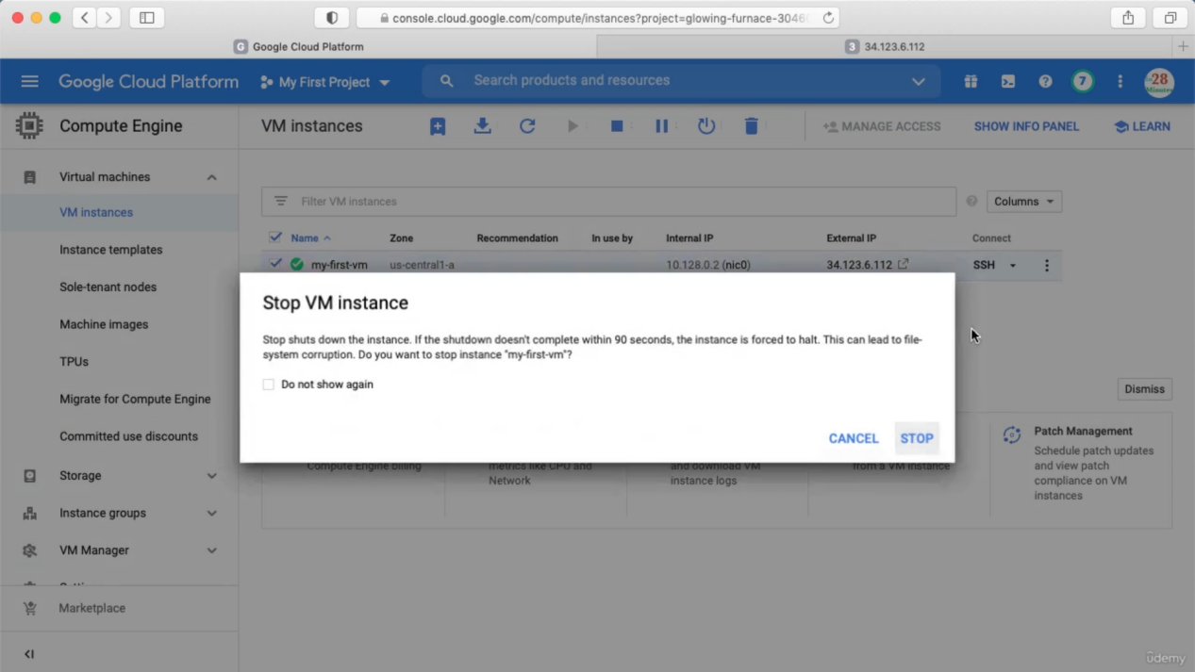

Releasing Static IP. You can delete the vm associated with this static IP. You will be billed more when you are not using the static ip then when you are using it.  
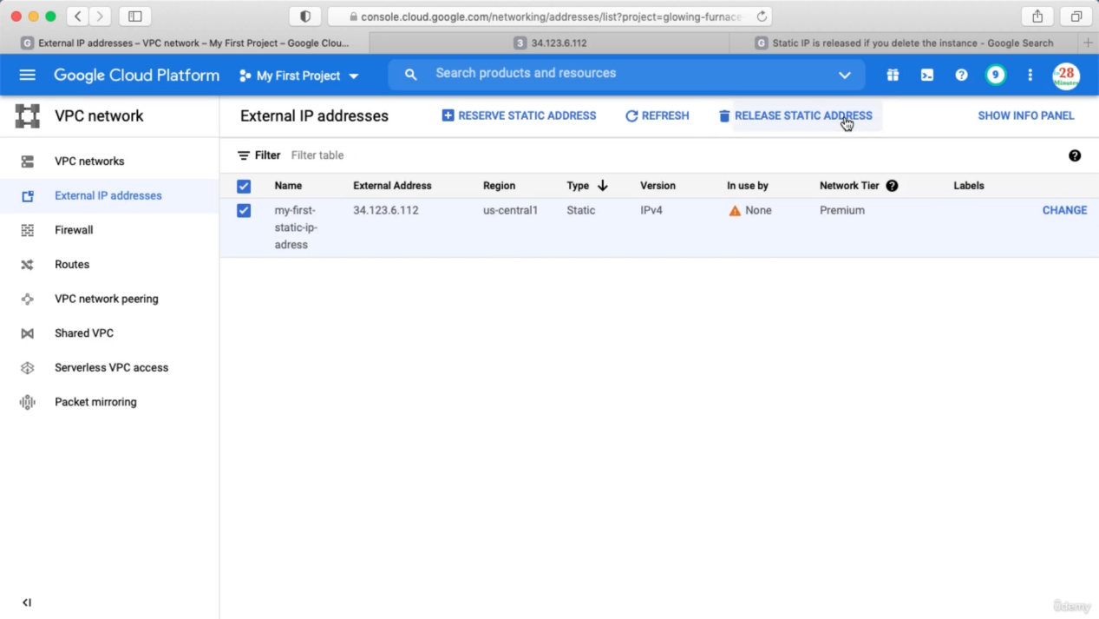

==================================================

Creating VM instances with Start up Script.

In the Search box type VM instances and click create.

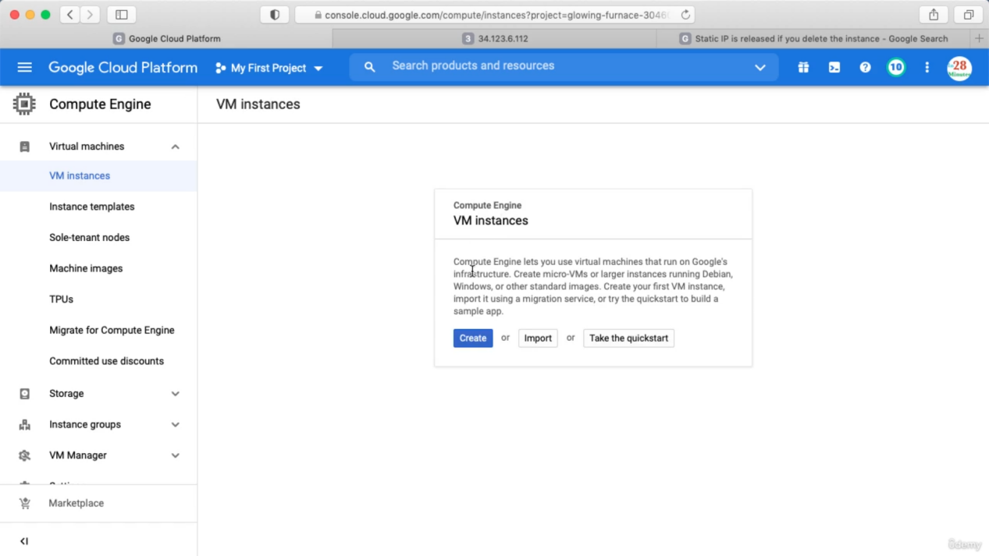

Label adds more information about the VM. Check Allow HTTP trafic for external uses.

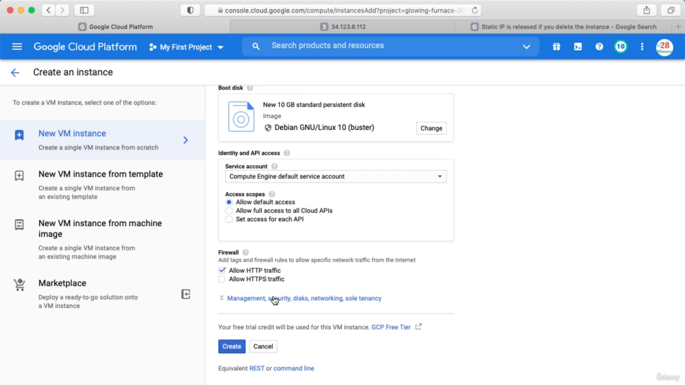

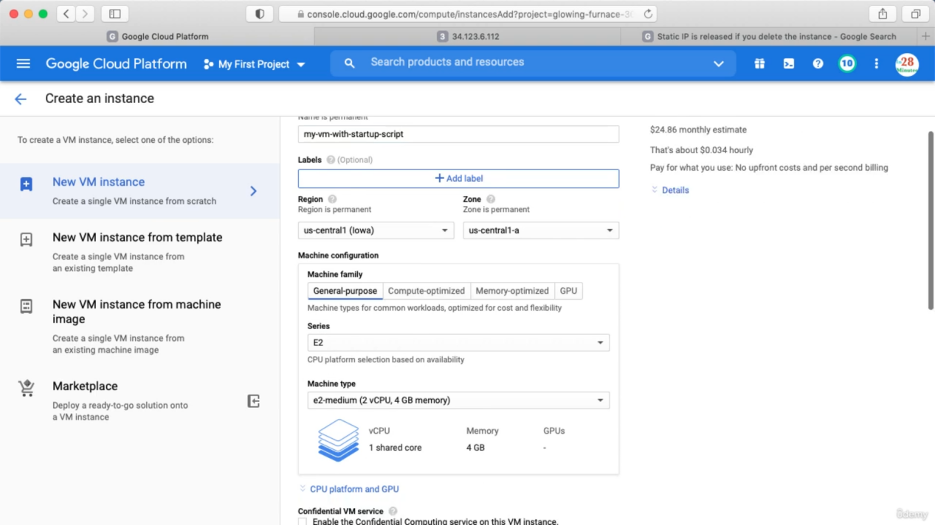

Click below

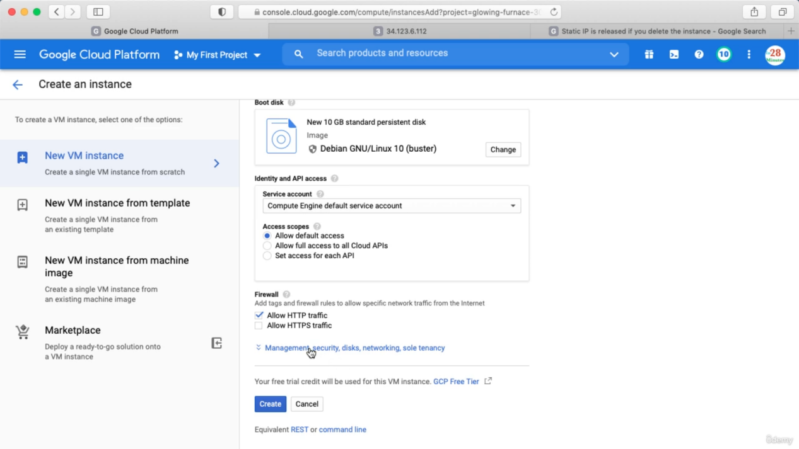

Add below in startup script

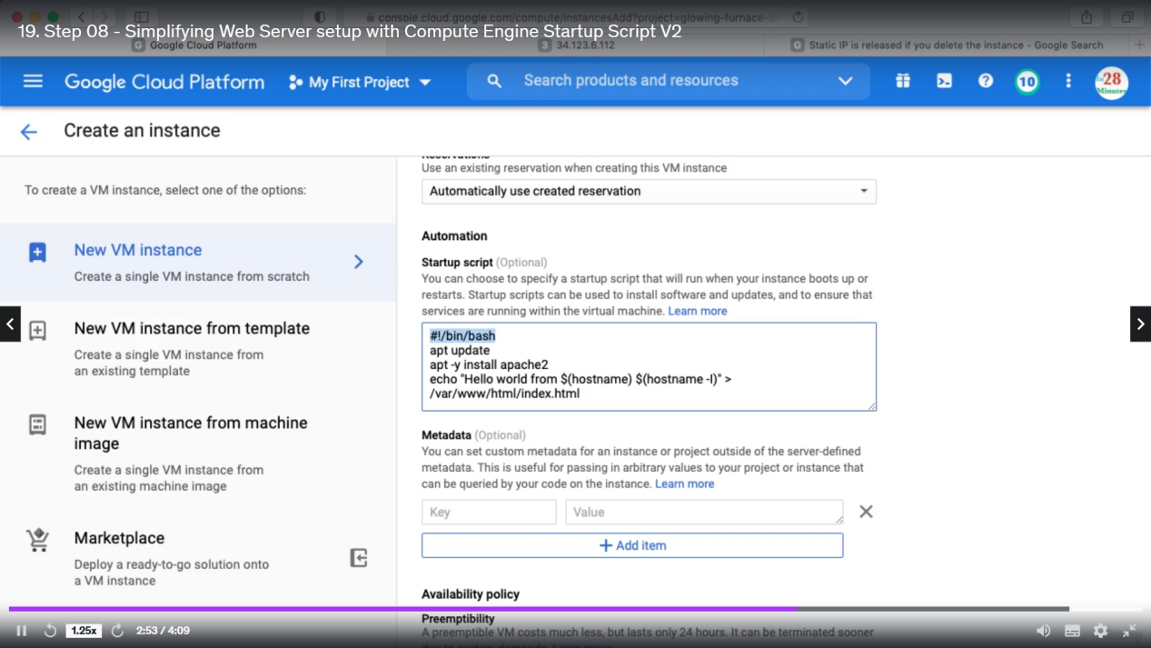

Now click create.

Creating VM using instance template

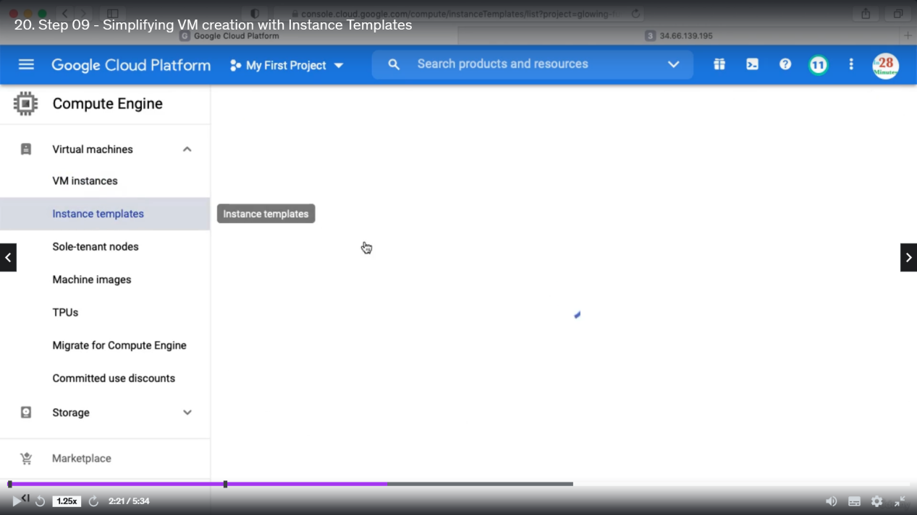

Fill up similar details and click create

.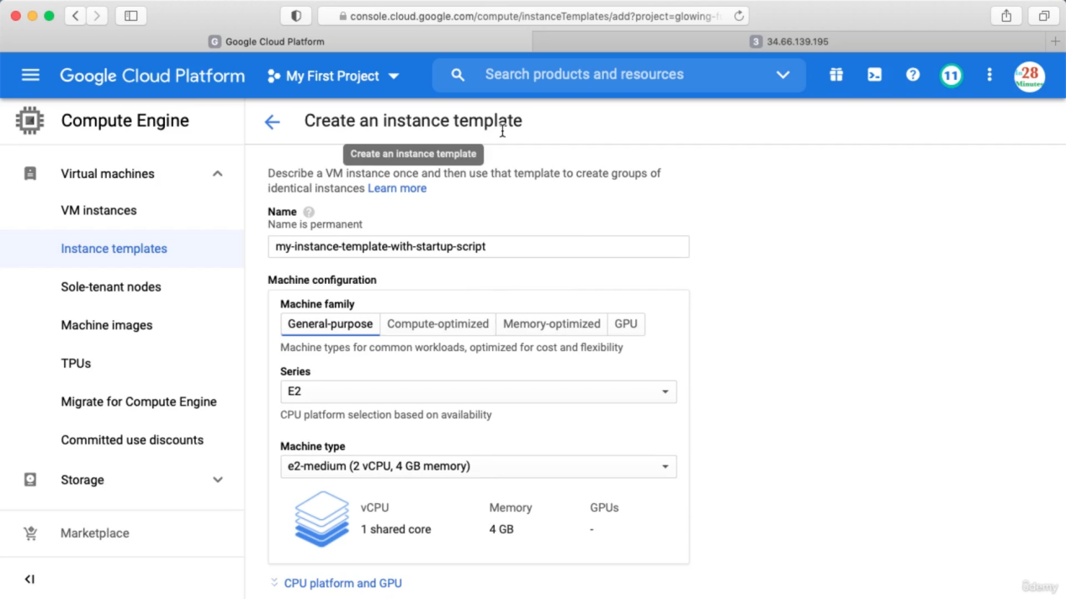

After creating below instance template will be created. There is no cost associated with instance template but when we create instance from instance template then cost will be deducted.

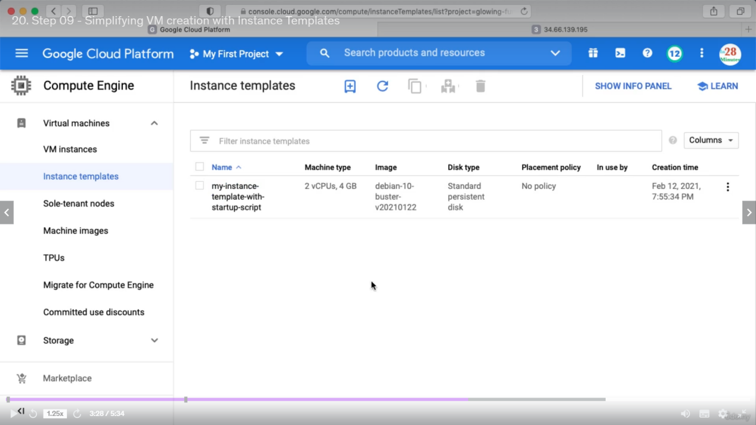

When creating instance template we do not specify Regions and Zones but while creating VM from template we specify Regions and Zones.

Create instance from instance template

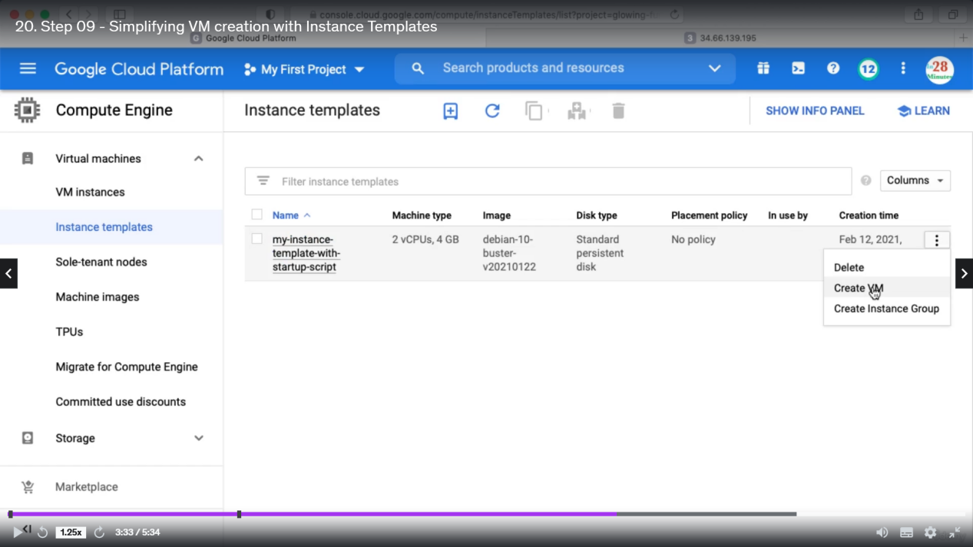

Then after selecting Region and Zone click create.

Reducing Launch Time

We can create image from an instance and then create VM from that image. This will reduce the launch up time.

Creating Custom image

If you click on Disk, you can see the Hard Disks associated with your virtual machine

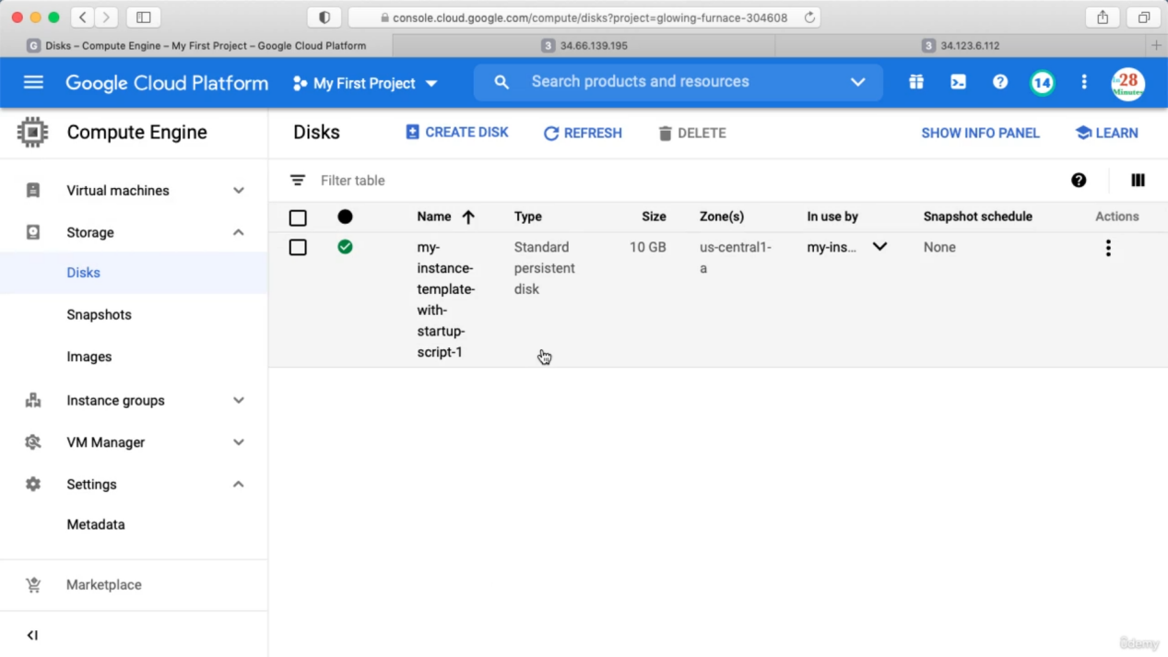

The name is same as the VM name. Click Actions and create image

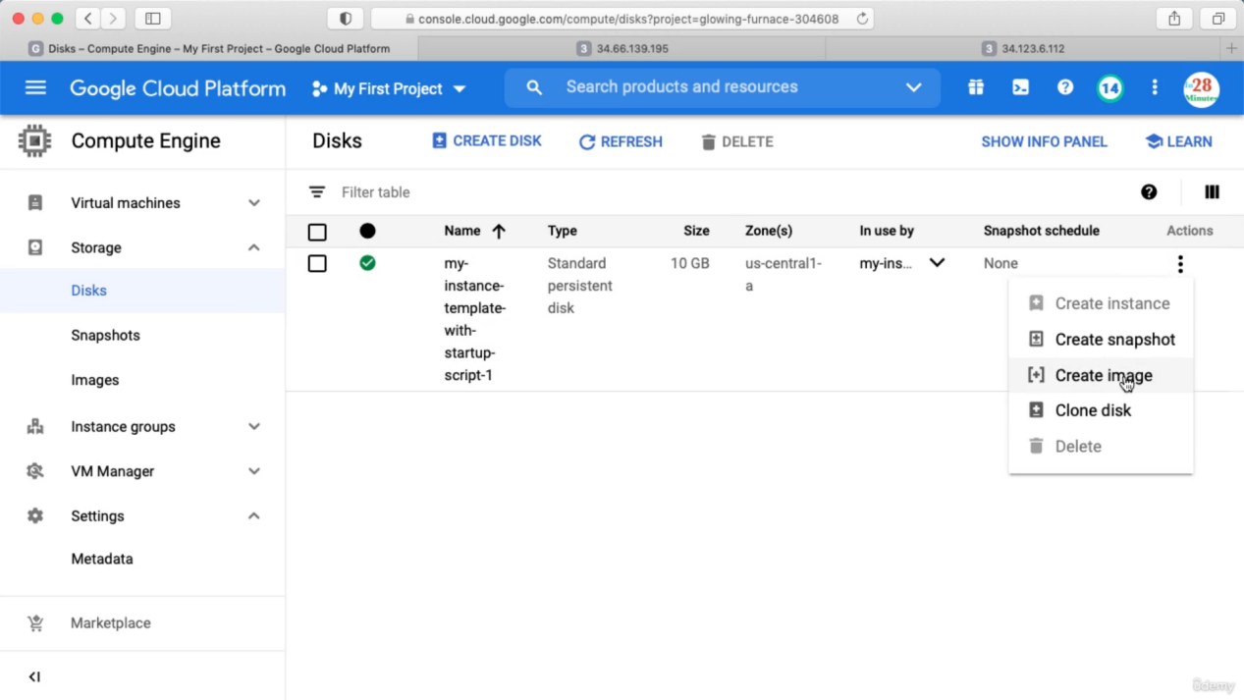

After this we need to select whether this image can be used to multiple region or a single region. Also we should not create any image from a Disk which is associated with a running instance.

Now from this image we can create a VM instance

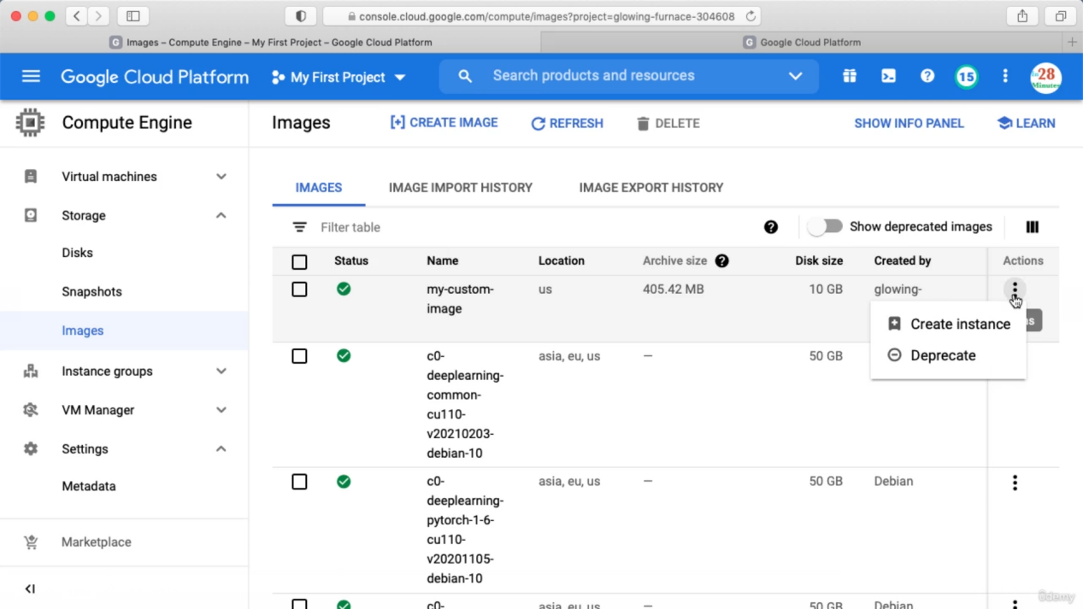

We can also create a instance template based on this image. Copy an existing instance template as below

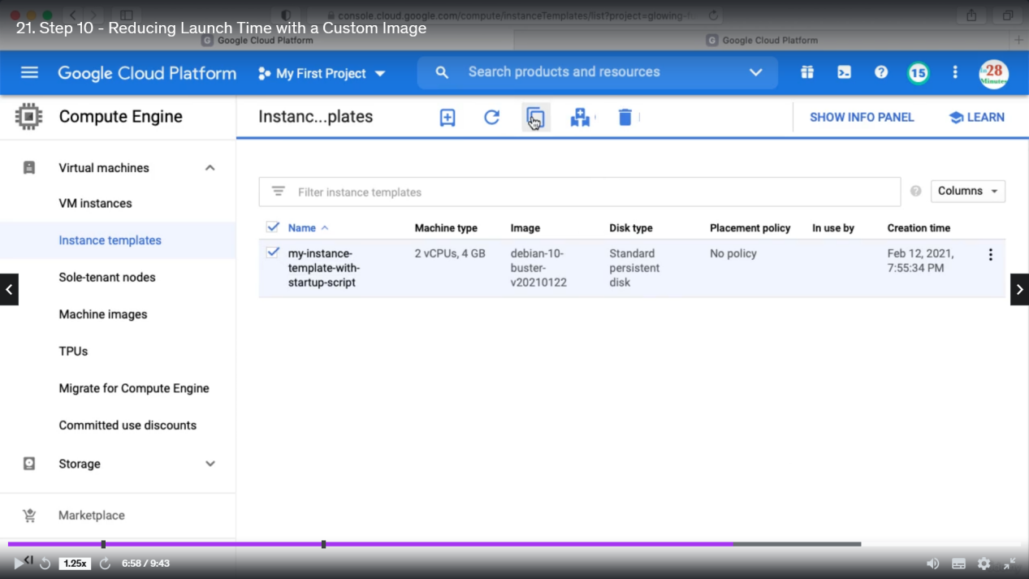

Rename the new template

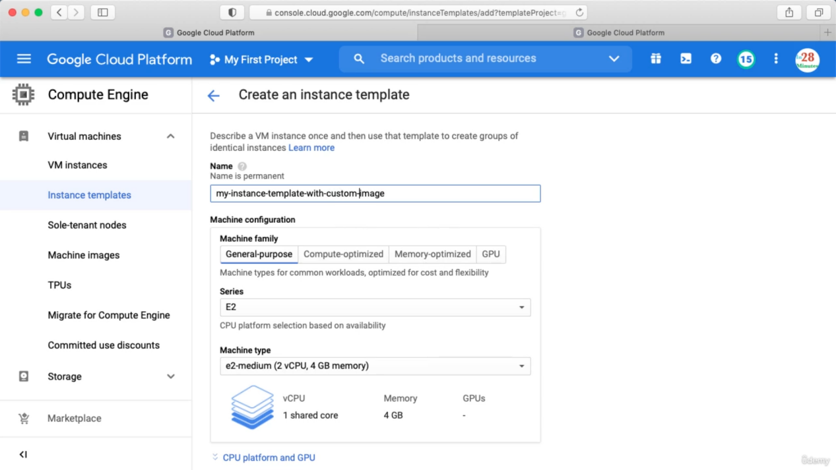

In the Boot Disk, change this to custom image

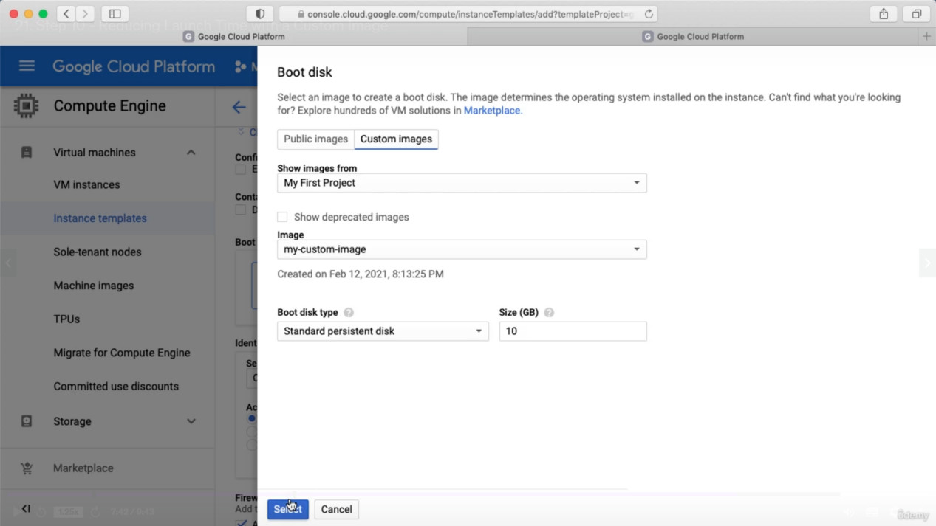

In the start up script we don’t need to install anything because apache is already installed in the custom image. Instead we need to start the service.

In the activity tab we can see whatever we are doing So far. We can filer this also.

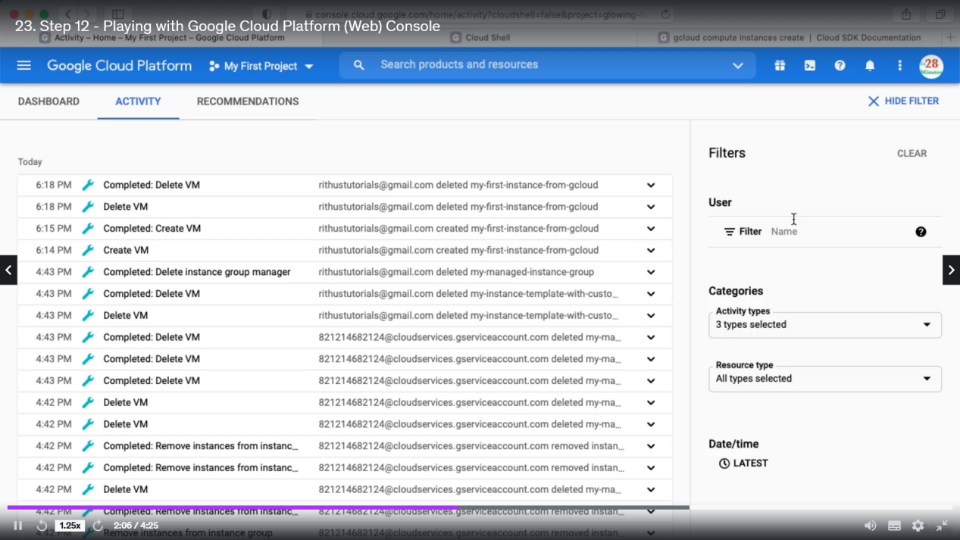

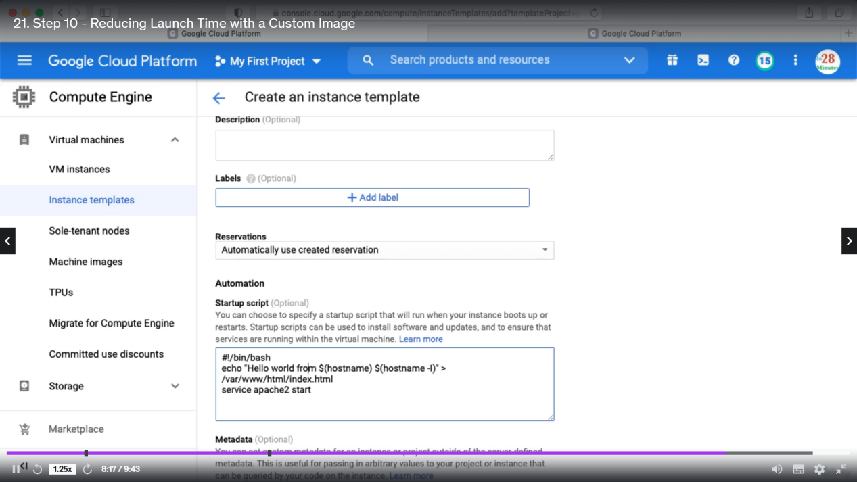

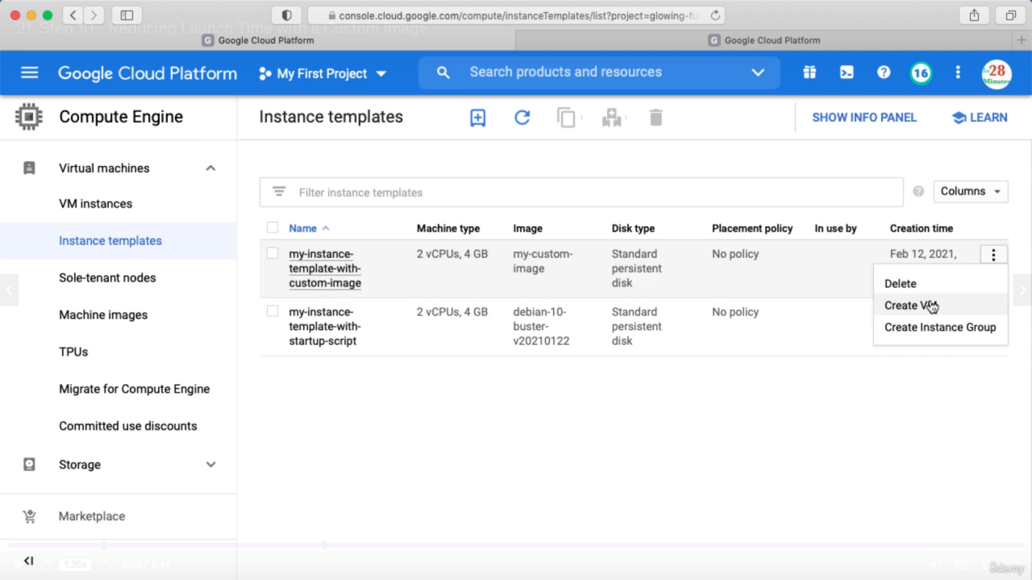

We must terminate all our VM instances after using.